Research protocol Assignment
Mode of Delivery and Risk of Postpartum Depression in the Early Postpartum Period: An Analytical Cross-Sectional Study

Belgin Ahmed Nagah
Galala University
Medical intern
01122264194
Wave one

Research Protocol
Title
Mode of Delivery and Risk of Postpartum Depression in the Early Postpartum Period: An Analytical Cross-Sectional Study

1.Background and Rationale
Postpartum depression (PPD) is a common mental health disorder affecting women after childbirth and represents an important public health concern due to its impact on both maternal and child health. Women with postpartum depression may experience persistent sadness, fatigue, anxiety, and difficulty caring for themselves or their newborns. In addition, PPD can negatively affect mother infant bonding, breastfeeding, and the child’s emotional and cognitive development. Therefore, early identification of women at risk is essential for timely intervention and support (Baba et al.,2021).
Several biological, psychological, and social factors have been associated with postpartum depression. Among these factors, the mode of delivery has received increasing attention, particularly with the global rise in cesarean section rates. Although cesarean delivery is sometimes medically necessary, it may be associated with increased physical stress, postoperative pain, longer recovery, and emotional distress, which may contribute to depressive symptoms in the postpartum period (Meky et al.,2019).
Previous studies suggest that postpartum depression may be more common among women who deliver by cesarean section compared with those who deliver vaginally. One cross-sectional study reported a higher prevalence of postpartum depression among women who underwent emergency cesarean section compared with vaginal delivery. In addition, a large systematic review and network meta-analysis involving more than 1.8 million participants found that both elective and emergency cesarean sections were associated with increased odds of postpartum depressive symptoms, with a stronger association observed for emergency cesarean delivery.(Sun et al.,2020).

Despite these findings, the relationship between mode of delivery and postpartum depression remains unclear because several factors, such as maternal mental health history, pregnancy complications, socioeconomic status, and social support, may influence this association(Baba et al.,2021). Therefore, further research is needed to better understand the relationship between delivery mode and postpartum depression. This study aims to investigate the association between mode of delivery and postpartum depression among women in the early postpartum period.
2. Research Question
Among women in the early postpartum period (4-8 weeks), does delivery via cesarean section (elective or emergency) compared to vaginal birth increase the risk of postpartum depression?

3. Study Design
Analytical cross-sectional study

4. Participants
- Inclusion Criteria
- Women aged ≥18 years
- Women who delivered a live infant

- Exclusion Criteria
- Women with diagnosed psychiatric disorders before pregnancy
- Severe maternal medical complications

- Study Setting
- The study will be conducted at the obstetrics and gynecology outpatient clinics of El-Demerdash hospitals, Egypt.

5. Variables
- Predictor Variable
- Mode of delivery

- Outcome Variable
- Postpartum depression measured by Edinburgh Postnatal Depression Scale (EPDS)

- Confounding Variables
- Maternal age
- Parity
- Previous depression
- Pregnancy complications
- Socioeconomic status
- Educational level
- Pregnancy intention

6. Hypotheses
- Null hypothesis (H₀):
There is no statistically significant association between mode of delivery and postpartum depression among postpartum women.
- Alternative hypothesis (H₁):
There is a statistically significant association between mode of delivery and postpartum depression among postpartum women.
7. Sample Size
The sample size was calculated based on the expected difference in the prevalence of postpartum depression between delivery modes as reported in previous studies. Previous research reported a prevalence of approximately 7% among women who delivered vaginally compared with 25% among women who underwent emergency cesarean section.
Using a confidence level of 95% (α = 0.05) and a statistical power of 80%, the minimum required sample size was estimated to be 120 participants, with 60 women in each group (vaginal delivery and emergency cesarean section).
To compensate for possible non-response or incomplete data, an additional 10% will be added, resulting in a final estimated sample size of approximately 132 participants.
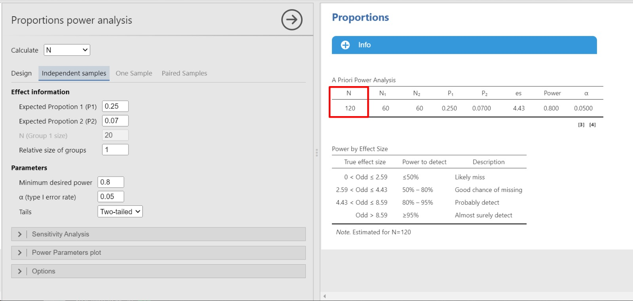
8. Analytic Approach
Data collected from participants will be entered and analyzed using the Statistical Package for the Social Sciences (SPSS) software.
Descriptive statistics will be used to summarize the characteristics of the study participants. Continuous variables such as age will be presented as mean ± standard deviation, while categorical variables such as mode of delivery will be presented as frequencies and percentages.
Postpartum depression will be assessed using the Edinburgh Postnatal Depression Scale (EPDS), and a score of 13 or higher will be considered suggestive of postpartum depression.
The relationship between mode of delivery and postpartum depression will be examined using the Chi-square test.
In addition, logistic regression analysis will be performed to identify whether mode of delivery is an independent factor associated with postpartum depression after adjusting for other relevant variables.
A p-value less than 0.05 will be considered statistically significant.

9.Data Collection Procedure
Eligible participants will be recruited from the obstetrics and gynecology outpatient clinics of El-Demerdash hospitals during routine postpartum visits. Women who meet the inclusion criteria will be invited to participate and written informed consent will be obtained. Data will be collected using a structured questionnaire including socio-demographic characteristics, obstetric history, and mode of delivery. Postpartum depression will be assessed using the Edinburgh Postnatal Depression Scale (EPDS). Each participant will complete the questionnaire once during the early postpartum period (4–8 weeks after delivery).

10.Ethical Considerations
Ethical approval will be obtained from the Institutional Review Board (IRB) of El-Demerdash hospitals before the start of the study. All participants will be informed about the purpose of the study and will provide written informed consent prior to participation. Participation will be voluntary, and participants will have the right to withdraw from the study at any time without affecting their medical care.
All collected data will be kept strictly confidential and used only for research purposes. Personal identifiers will not be included in the analysis, and all information will be stored securely.
Participants who score 13 or higher on the Edinburgh Postnatal Depression Scale (EPDS) will be referred for appropriate psychological evaluation or counseling.

11.Data Collection Form

https://forms.gle/AmVZ8CVC2fqdtah47

Refrences:
https://pubmed.ncbi.nlm.nih.gov/30704328/
Meky, H. K., Shaaban, M. M., Ahmed, M. R., & Mohammed, T. Y. (2019). Prevalence of postpartum depression regarding mode of delivery: a cross-sectional study. The Journal of Maternal-Fetal & Neonatal Medicine, 33(19), 3300–3307. https://doi.org/10.1080/14767058.2019.1571572

https://pubmed.ncbi.nlm.nih.gov/34334503/
Baba, S., Ikehara, S., Eshak, E. S., Ueda, K., Kimura, T., & Iso, H. (2021). Association between mode of delivery and postpartum depression: the Japan Environment and Children’s Study (JECS). Journal of Epidemiology, 33(5), 209–216. https://doi.org/10.2188/jea.je20210117

https://pubmed.ncbi.nlm.nih.gov/32929976/
Sun, L., Wang, S., & Li, X. (2020). Association between mode of delivery and postpartum depression: A systematic review and network meta-analysis. Australian & New Zealand Journal of Psychiatry, 55(6), 588–601. https://doi.org/10.1177/0004867420954284

